How to Add a New Worker

Choosing between a Permanent and Casual Employee
The process for adding Permanent and Casual Employees is very similar. Both require the same amount of information from the employee, the difference between them relates to the leave accruals and patterns of work.

Casual Employees have no pattern of work. To compensate for this, they are entitled to an additional 8% of their wages to cover the leave they would otherwise accrue. If you anticipate your employee to work irregular hours, then they should be on a casual contract.

For example, you may wish to have the employee come in to provide support for one weekend every couple of months but they are not required in between. This is casual work. If they are going to work 1 or 2 hours a week on different days, this is seen as permanent employment because they are needed each week.

For more information about the different types of employees, please see this link:
- https://www.employment.govt.nz/starting-employment/who-is-an-employee/types-of-employee/

Adding the Record in the Portal
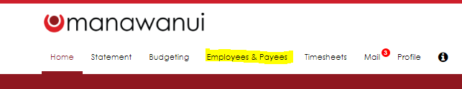
- Once you have logged into the Web Portal, click the ‘Employees & Payees’ tab:

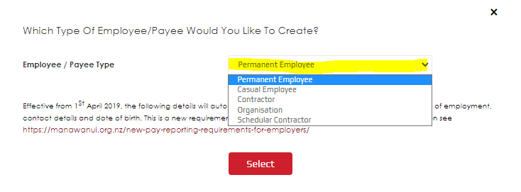
- On the right-hand side of your screen, click ‘Add Employee/Payee’ which will bring up a pop-up:

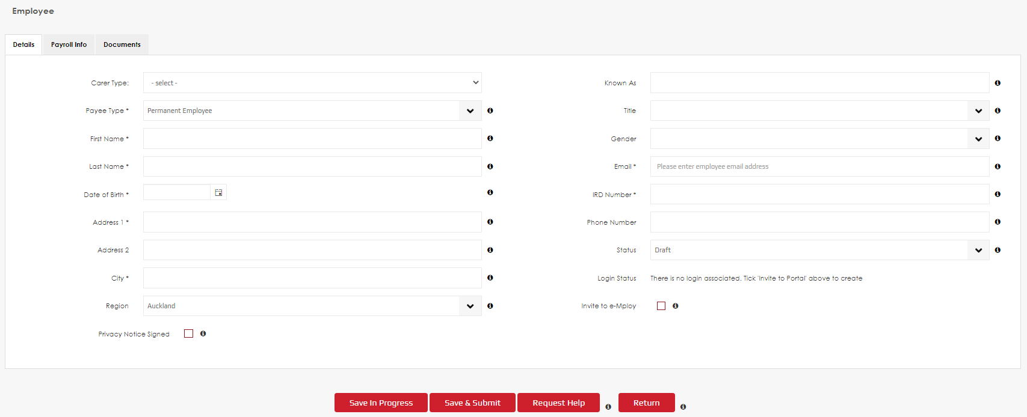
- Depending on the type or record you are looking to create, choose the relevant option then click Save. In this example, we are using the ‘Permanent Employee’. This will bring you into the new employee’s record:
Please note that if you choose to invite your employee to the Portal, they will have a status of ‘Pending’ until they have clicked the link in their email and set up a password.

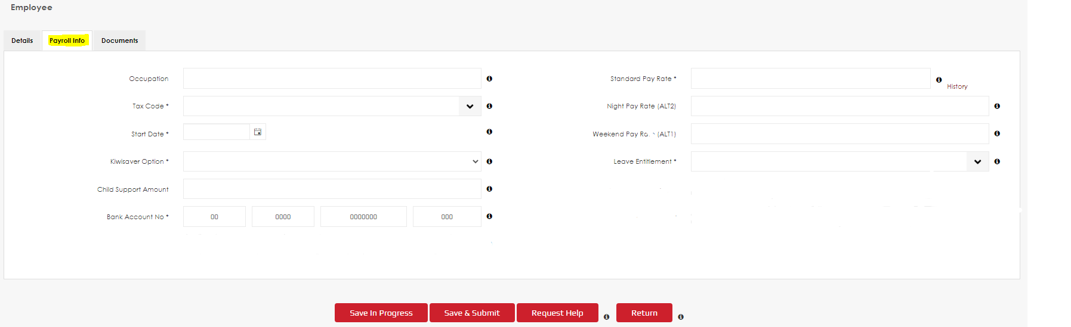
- Using the information your new worker provides, enter their details into the first tab (top left of the screen). All the fields that have an asterix are mandatory. When you have completed this tab, click into ‘Payroll Info’:
  - Please note that an IR330 and a bank verification is required. You can upload (and download) these in the ‘Documents’ tab.
  - For Casual Employees, the ‘Leave Entitlement’ will be ‘8% included in pay’.
  - For Permanent Employees, the ‘Leave Entitlement’ will be ‘Average’ unless they work 8 hours per day, 5 days per week, then it will be ’20 Days’.

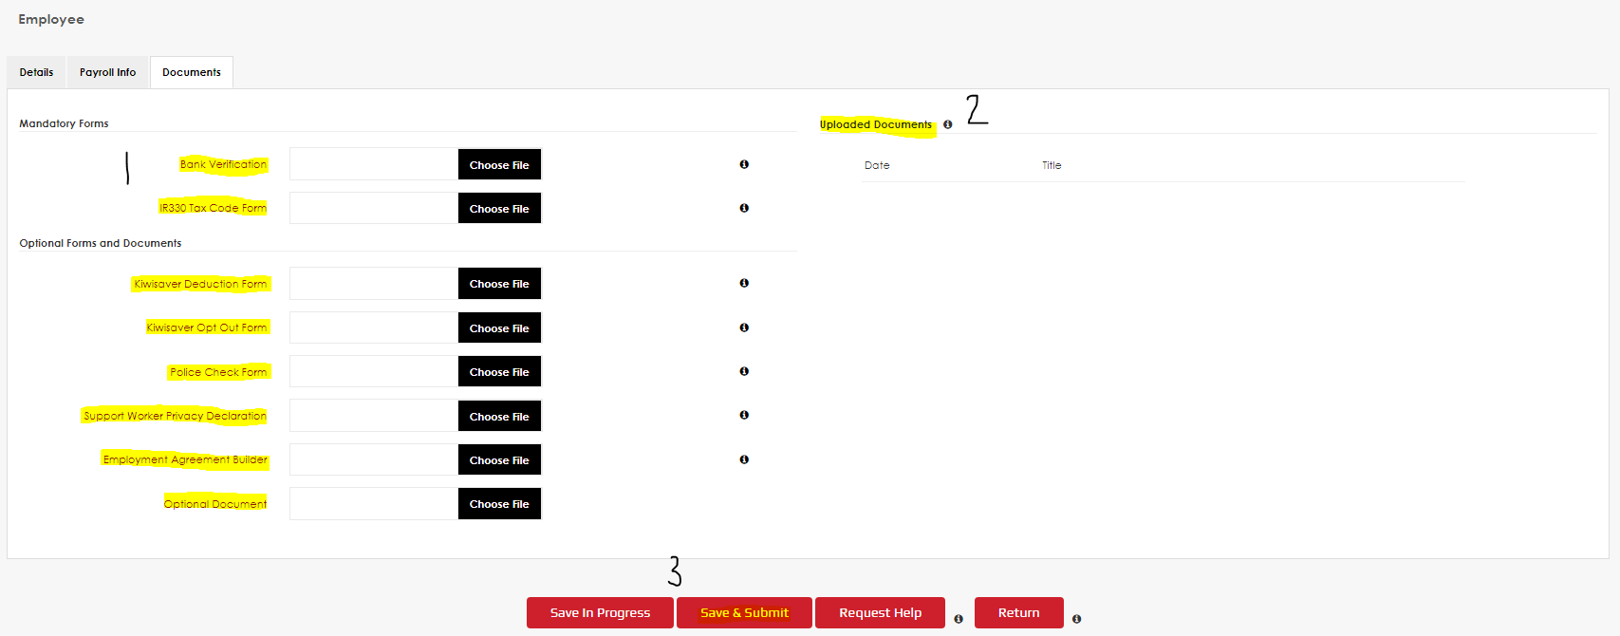
- Once you have filled in the relevant Payroll Information, you can click the ‘Documents Tab’ to upload or download any associated documents:
  - At point 1, if you click the title names, you can download the relevant forms except the ‘Bank Verification’ and the ‘Employment Agreement Builder’.
    - The Bank Verification your employee will need to get from their bank to confirm the account number provided is correct.
    - The Employment Agreement Builder will direct you to the below website so you can create your own agreement and save it for when you hire new employees
      - https://eab.business.govt.nz/employmentagreementbuilder/startscreen/
  - At point 2 will be where all uploaded documents can be accessed
  - At point 3 you can either save the record and come back later (Save In Progress) or Save and Submit to activate the record.
- When you have finished adding all relevant information and documents, and you have clicked ‘Save and Submit’, you will immediately be able to start submitting timesheets for hours worked by that employee.

Choosing between a Contractor or Schedular Contracting
As the Employer, if you are eligible to pay yourself as the Resident Family Carer you can set yourself up as either a Contractor or a Schedular Contractor. The primary difference between these is that for a Schedular Contractor we will take care of your Withholding Tax and you will be responsible for the ACC Levies and KiwiSaver payments. As a Contractor you will be responsible for all tax, ACC Levies and KiwiSaver payments.

Adding a Contractor Record
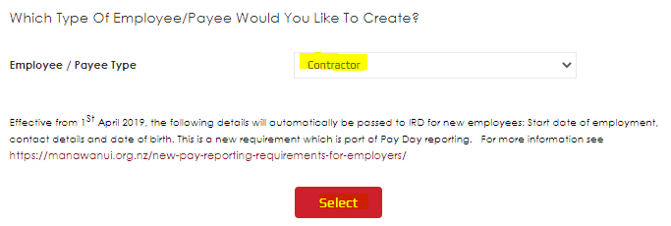
- From the ‘Employees & Payee’s tab, click ‘Add Employee/Payee’ on the right-hand side of the screen. In the pop-up, click ‘Contractor’ then ‘Select’.

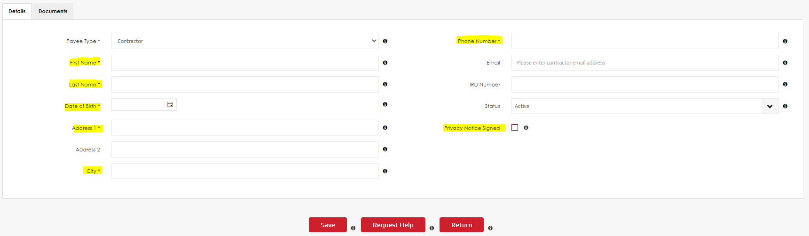
- Clicking ‘Select’ will take you into the record where you will need to enter the details of the Contractor:
- The mandatory fields are:
  - Full Name
  - Date of Birth
  - Physical Address
  - Contact Phone Number
- Remember to click ‘Save’ when you have entered all information.

Adding a Schedular Contractor Record
As we deduct the Withholding tax on your behalf, we require additional information to meet Payroll legislation. Please also upload a completed IR330c which nominates the Withholding Tax rate for us to deduct. If you are unsure on the correct percentage, please contact IRD for their advice. Each individual will have a different rate depending on their circumstances.
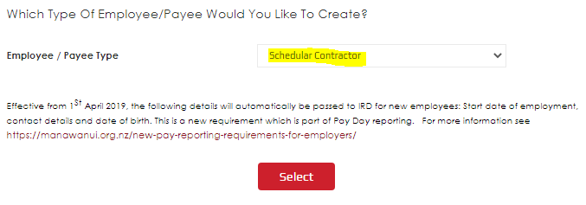
- From the ‘Employees & Payee’s tab, click ‘Add Employee/Payee’ on the right-hand side of the screen. In the pop-up, click ‘Schedular Contractor’ then ‘Select’.

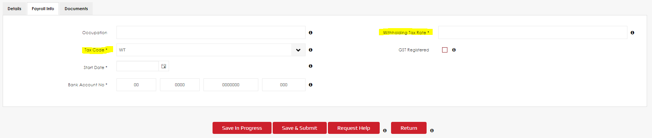
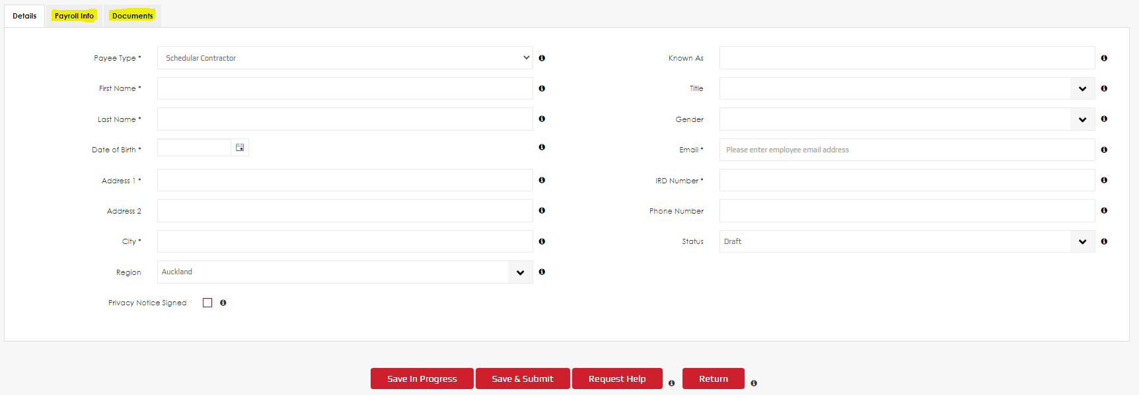
- You will notice that there is a ‘Payroll Info’ tab for Schedular Contractors, we are unable to make payments without this information. Please enter your Details, then click ‘Payroll Info’ to enter that information:
Take note that in the ‘Payroll Info’ tab the only tax code that can be selected is ‘WT’. The important thing to get accurate is the tax rate. If you choose a percentage that is too low, then you may incur a tax bill at the end of the financial year. Please seek advice from IRD if you are unsure which rate to nominate.

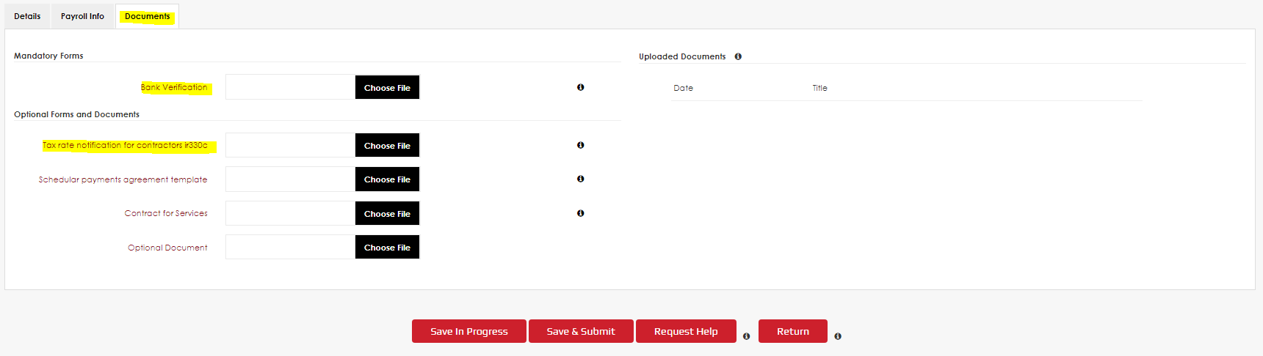
- When you have uploaded the IR330c and Bank Verification to the ‘Documents’ tab please ‘Save and Submit’ the record to enable you to submit a timesheet for your Schedular Contracting payments. You can also download the document from this tab if you need to amend it in the future:

